

PANGANI GIRLS’ KCSE PREDICTION
EXAM TEST-2025
443/2
AGRICULTURE
PAPER 2
TIME: 2 HOURS

NAME…………………………………………………………………………………………
SCHOOL………………………………………………. SIGN……………………..
INDEX NO ……………………………………………. DATE…………………….

Kenya Certificate of Secondary Education.

INSTRUCTIONS TO CANDIDATES
- Write your name, school and index number in the spaces provided above
- Sign and write the date of examination in the spaces provided above.
- This paper consists of three sections A,B and C
- Answer All the question in section A and B
- Answer ANY TWO questions in section C
- All answers should be written in the space provided in the question paper.

FOR EXAMINER’S USE ONLY
Section | Question | Maximum | Candidate’s score
A | 1-18 | 30
B | 19-22 | 20
C |  | 20
 |  | 20
 | TOTAL SCORE | 90

SECTION A
Answer All the Questions In This Section In The Spaces Provided
- Name two dairy goat breeds found in Kenya. (1 Mk)
………………………………………………………………………………………………………
………………………………………………………………………………………………………
………………………………………………………………………………………………………

- Outline four reasons for maintaining farm tools and equipment in good condition. (2 Mks)
………………………………………………………………………………………………………
………………………………………………………………………………………………………
………………………………………………………………………………………………………
………………………………………………………………………………………………………
………………………………………………………………………………………………………

- Outline two predisposing factors of foot rot. (1 Mk)
………………………………………………………………………………………………………
………………………………………………………………………………………………………
………………………………………………………………………………………………………

- Name two rules that should be observed when milking. (1 Mks)
………………………………………………………………………………………………………
………………………………………………………………………………………………………
………………………………………………………………………………………………………

- Outline two duties of a worker bee in a colony of bees. (1 Mks)
………………………………………………………………………………………………………
………………………………………………………………………………………………………
………………………………………………………………………………………………………

- Study the table below fill in the blanks to show the term used to refer to parturition and young ones of the following animals. (2 Mks)
Type of animal | Act of parturition | Term to refer to the young one
Cattle | Calving | Calf
Goats | ………………………………… | …………………………………..
pig | …………………………………. | …………………………………..

- State four harmful effects of ticks. (2 Mks)
………………………………………………………………………………………………………
………………………………………………………………………………………………………
………………………………………………………………………………………………………
………………………………………………………………………………………………………

- State four desirable factors to consider when siting a fish pond. (2 Mks)
………………………………………………………………………………………………………
………………………………………………………………………………………………………
………………………………………………………………………………………………………
………………………………………………………………………………………………………

9. Name the most appropriate tools used in the following operations
a) Removing metal chippings in file (1mrk)
………………………………………………………………………………………………………

b) Cutting wood along grains (1mrk)
………………………………………………………………………………………………………

c) Branding (1mrks)
………………………………………………………………………………………………………

10. State four characteristic of Boran cattle (2mrks)
………………………………………………………………………………………………………
………………………………………………………………………………………………………
………………………………………………………………………………………………………
………………………………………………………………………………………………………

11. Name three methods of out breeding in livestock production (1 ½ marks)
………………………………………………………………………………………………………
………………………………………………………………………………………………………
………………………………………………………………………………………………………

12 .What do you understand by the following terms as used I animal production .
- Caponisation (1mrk)
………………………………………………………………………………………………………
………………………………………………………………………………………………………
b) Bullock (1mrk)
………………………………………………………………………………………………………
………………………………………………………………………………………………………
c. Epistasis (1mrk)
………………………………………………………………………………………………………
………………………………………………………………………………………………………

13.State four control measures of a liver fluke in livestock. (2 marks)
………………………………………………………………………………………………………
………………………………………………………………………………………………………
………………………………………………………………………………………………………
………………………………………………………………………………………………………

14.What is “dry cow therapy” in dairy cattle management? (1/2 mark)
………………………………………………………………………………………………………
………………………………………………………………………………………………………

15.State four causes of stress in poultry. (2 marks)
………………………………………………………………………………………………………
………………………………………………………………………………………………………
………………………………………………………………………………………………………
………………………………………………………………………………………………………

16.Distinguish between mothering ability and prolificacy as used in livestock breeding.(1mks)
………………………………………………………………………………………………………
………………………………………………………………………………………………………
………………………………………………………………………………………………………

17. Name two sources of protein for livestock nutrition. (2 marks)
………………………………………………………………………………………………………
………………………………………………………………………………………………………

18.State four signs of parturition shown by a in calf cow. (2 marks)
………………………………………………………………………………………………………
………………………………………………………………………………………………………
………………………………………………………………………………………………………
………………………………………………………………………………………………………

SECTION B ( 20 mks)
Answer All The Questions In This Section
19.The diagram below shows a certain practice carried out on pig
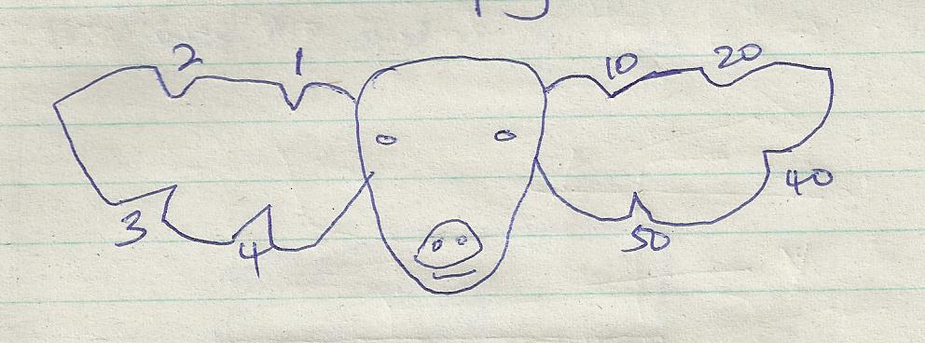

- Identify the practice illustrated above (1mrk)
………………………………………………………………………………………………………

- Draw another illustration depicting pig number 37 (1mrk)

- Name the tool used to carry out the practice illustrated above (1mrk)
………………………………………………………………………………………………………

- State two other method of identifying piglet (2mrks)
i)…………………………………………………………………………………………………
ii)…………………………………………………………………………………………………

20. The diagrams below show some farm tools. study them and answer the question that follow.
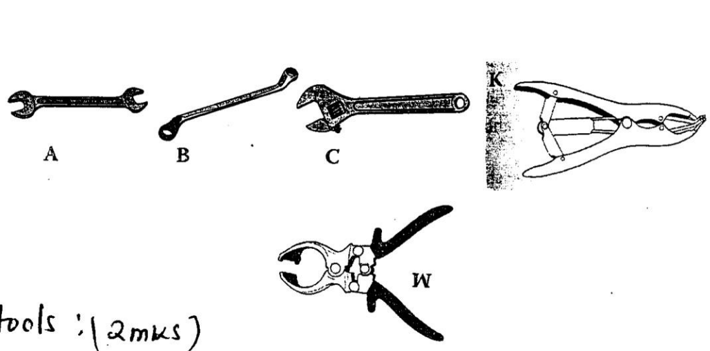
K

a) Name the tools. (2 marks)
A………………………………………………………………………………………………..
B…………………………………………………………………………………………………
C…………………………………………………………………………………………………
W…………………………………………………………………………………………………

- State the functional differences between tools K and W. (1 mark)
………………………………………………………………………………………………………
………………………………………………………………………………………………………
………………………………………………………………………………………………………

c) What advantage does C have over A and B? (1 mark)
………………………………………………………………………………………………………
………………………………………………………………………………………………………
- State one common maintenance practice carried out in tool C and W. (1 mark)
.....................................................................................................................................................................................................................................

21a) The diagram below shows a structure of the udder of a cow. Name the part labeled W, X, Y and Z. (2 marks)
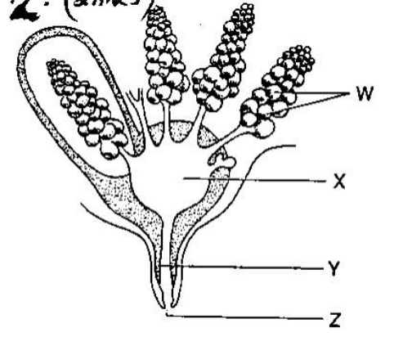

W………………………………………………………………………………………………
X……………………………………………………………………………………………
Y………………………………………………………………………………………………
Z ……………………………………………………………………………………………….

- What is milk let down (1 mrk)
………………………………………………………………………………………………………
………………………………………………………………………………………………………

c) Name two hormones that control milk let down in dairy cow. (2 mrk)
………………………………………………………………………………………………………
………………………………………………………………………………………………………

22. Below is an illustration of a method of extracting honey from combs .Study the diagram and answer the question that follow.
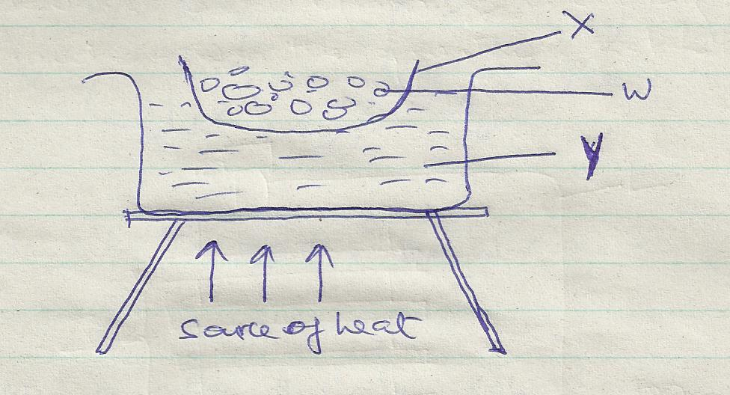
- Identify the above method of extracting honey (1mrk)
………………………………………………………………………………………………………

- Give a reason why container x should not be heated directly (1mrk)
………………………………………………………………………………………………………
………………………………………………………………………………………………………

- Name the parts labeled w and y (2mrks)
W………………………………………………………………………………………………… Y…………………………………………………………………………………………………

- Besides the above method ,State one other method of extracting honey (1mrk)
………………………………………………………………………………………………………

SECTION C (40 MKS)
Answer Any Two Questions In This Section
23(a) State five reasons why bees swarm. (5 marks)
b) Describe five maintenance practices carried out on a tractor battery. (5 marks)
c) Explain five factors considered when culling livestock. (5 Mks)
d. Explain five mechanical methods of controlling ticks. (5 mks)

24a) Describe the process of egg formation in chicken up to the point of laying. (10 Mks)
b) State the differences between four stroke cycle and two stroke cycle engine. (5 Mks)
c) Describe the process of digestion in rumen. (5 Mks)

25. a) Describe trypanosomiasis disease under the following sub-headings.
i) Causal organism (1 Mk)
ii) Animal attacked (1 Mk)
iii) Five symptoms of attacked animals (5 Mks)
iv) Three control measures (3 Mks)
b) Control five control measures for cannibalism (5 Mks)
(c) Explain five parts of a piggery unit (10mrks)

